Secure your Reka-Lunch credit now
Benefit from discounted meals provided by your employer
Simply pay your share via QR invoice or eBill and boost your food budget. Important: Your entitlement to discounted Reka-Lunch credit is time-limited – make sure to secure it in time. Credit you’ve already paid remains valid indefinitely.

Over 3,500 places to redeem: coffee, snacks, lunch, and more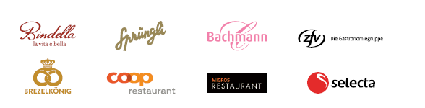

How it works:
- Access the QR invoice in the customer portal at reka.ch or receive it via eBill in your e-banking.
- Make the payment.
- Pack your Reka-Card and enjoy delightful moments.

If you do not have the documents, your Human Resources department will be happy to assist you.
We wish you lots of enjoyment with Reka-Lunch.

